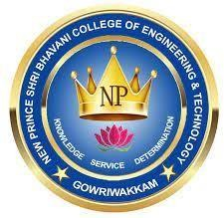

NEW PRINCE SHRI BHAVANI COLLEGE OF ENGINEERING AND TECHNOLOGY

(An Autonomous Institution)
(Approved by AICTE / Affiliated to Anna University, ISO 9001:2015 Certified Institution/Recognized by UGC under section 2(f) of UGC Act 1956/Top 50 in ARIIA 2020 / Gold Rating - AICTE CII Survey 2020)

ANNEXURE–I
New Prince Shri Bhavani College of Engineering and Technology, Chennai
Industry Feedback Form for Fourth semester Internship
Department of Artificial Intelligence And Data Science
JOINING REPORT

Register Number of the Student | 411423243045
Name of the Student | RAMAKRISHNAN VISHWAM P
Assigned Project | Full Stack Development
Name & Address of the Organization | NOVITECH R&D Pvt. Ltd.
Contact number | 9092038274
E-mail | novitech.vlsi@gmail.com
Address of the site(at which the student is physically deputed) | No 2B, 2nd Floor, Sai Shruthi Building, Ramar Kovil Street, Ram Nagar, Coimbatore – 641009
Contact number | 9092038274
E-mail | novitech.vlsi@gmail.com
Name of the Industry Mentor assigned | Bharani Chandar S
Designation | Software Developer
Contact number | 9597976451
E-mail | learn@novitechrd.com
I hereby inform that I have joined the organization on 01/06/2025 for the Internship with information above.
Dated: 01/06/2025

Signature of the Student
CERTIFICATE BY THE COORDINATOR IN THE INDUSTRY
Certified that the above-mentioned student has joined our organization for the internship semester under my supervision. Dated:01/06/2025
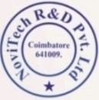
Signature of the Coordinator
(With Seal)

ANNEXURE–II

SUMMARY

Full Stack Development refers to the process of designing and building both the front-end (client-side) and back-end (server-side) components of a web application. A Full Stack Developer is skilled in various technologies used in developing a complete web application, including user interface design, server logic, database management, and API integration.
Front-End: Involves technologies like HTML, CSS, and JavaScript, along with frameworks like React, Angular, or Vue.js, to create responsive and interactive user interfaces.
Back-End: Focuses on server-side logic using languages like Node.js, Python, Java, or PHP, and frameworks such as Express.js, Django, or Spring. It also includes working with databases like MySQL, MongoDB, or PostgreSQL.
Key Skills:
- HTML/CSS/JavaScript
- Front-end frameworks (e.g., React, Angular)
- Back-end technologies (e.g., Node.js, Django)
- Databases (SQL and NoSQL)
- RESTful APIs and web services
- Version control (e.g., Git)

ANNEXURE–III
New Prince Shri Bhavani College of Engineering and Technology,
Chennai

Department of : Artificial Intelligence And Data Science

INTERNSHIP (Academic Year: 2024-2025)

INTERNSHIP REPORT

(Full Stack)

Submitted by

RAMAKRISHNAN VISHWAM P : 411423243045

Under the Guidance of

BHARANI CHANDAR BHARANI CHANDAR
(SOFWARE DEVELOPER) (SOFTWARE DEVELOPER NOVITECH R&D Pvt. Ltd.)

ANNEXURE–IV

New Prince Shri Bhavani College of Engineering and Technology, Chennai
Department of Artificial Intelligence And Data Science

INDUSTRY FEEDBACK FORM FORINTERNSHIP

Internee’s Information
Name | RAMAKRISHNAN VISHWAM.P
Register Number | 411423243045
Date of Joining(Internship) | 01/06/2025
Date of Completion(Internship) | 02/07/2025
Interaction officer for Industry

Name | Bharani Chandar S
Designation | Software Developer
Company’s/Organization’s Name | NoviTech R&D Pvt. Ltd.
Company Address | No 2B, 2nd Floor, Sai Shruthi Building, Ramar Kovil Street, Ram Nagar, Coimbatore - 641009
Phone | 9092038274
Mobile No. | 9597976451
Email ID | learn@novitechrd.com
Fax. No. | Nil
To be filled by the Evaluator
Please tick mark in the relevant box in the following grade chart for the Internee
Sl.  No. | Parameters | Excellent | Very  Good | Good | Satisfactory | Unsatisfactory
1 | Intelligence/ Learning aptitude | 
2 | Professional Skill/Knowledge |  | 
3 | Work Output/ Performance |  | 

4 | Expression | 
5 | Initiative & Drive | 
6 | Punctuality/ Regularity |  | 
7 | Honesty/Integrity | 
8 | Co-operation & Tact | 
9 | Discipline |  | 
10 | Interpersonal Skills |  | 
11 | Dedication to wards work |  | 
12 | Overall performance |  | 

A+=Excellent, A= Very Good, B=Good, C=Satisfactory & D=Unsatisfactory

- Did the Intern meet your expectations? Yes
- Would you like to take NPSBCET students again in next year ? Yes
- Do you think that the Institute can interact with the industry/ organization in some other way also? Please specify Yes
- Did you offer your intern any further employment? NO If yes, Package & Joining Details
- Any other suggestions/feedback: Nil


Signature & Stamp of the Interaction officer for Industry

ANNEXURE–V
New Prince Shri Bhavani College of Engineering and Technology, Chennai
Department of Artificial Intelligence And Data Science

INTERNSHIP (Academic Year: 2024-2025)

STUDENTS FEEDBACK FORM
- Name and Place of the Industry: NoviTech R&D Pvt. Ltd.

- Student’s Name: RAMAKRISHNAN VISHWAM P

- Student Register Number: 411423243045

- Are you satisfied with the manner the department did your:
  - Placement in various industrial units : Satisfied
  - Registration & Orientation : Satisfied
  - Evaluation : Satisfied If not satisfied, please give your suggestions overleaf.

- Was the technical assistance/guidance received from the Institute
satisfactory? If not, identify the areas where assistance was
lacking? Satisfied
- Specify be low areas of the project carried out by you Analysis& Design

- What additional subjects did you study in order to successfully complete the projects in the industry? Web Development

8 | PROJECT | SUBJECT
 | E Commerce website | Full Stack Development
9 | Problems faced in the industry regarding: |  | Yes | No
 | Project identification |  | 
 | Problem analysis |  | 
 | Implementation of the Project |  | 
 | Acceptance in Industry |  | 
 | Recognition of the work done by you |  | 
10 | Has the internship proved to bean exercise that has enhanced your Personal Attributed at work: |  | 
 | Communications Skills |  | 
 | Confidence level |  | 

 | Creativity | 
 | Planning skills | 
 | Adaptability | 
 | Being methodical | 
 | Organizational skills | 
11 | Technical Aspects | 
 | Knowledge | 
 | Skill at work | 
 | Were you provided the following: | 
 | Stipend |  | 
 | Accommodation |  | 
 | Conveyance |  | 
12 | Would you work for this company again |  | 
13 | Would you recommend this organization to  Other students? | 
14 | Why or why not | Why Not
15 | Any additional information/suggestion for further improvement of the project: | B
A– Excellent B–Good C – Fair

ANNEXURE–VI
- LEARNING OUT COMES

Skills Developed During the Internship:
- Front-End Development: Built responsive and interactive web pages using HTML, CSS, and JavaScript. Gained hands-on experience with front-end frameworks such as React.js or Angular.
- Back-End Development: Developed and maintained server-side applications using Node.js, Express, or other backend technologies.
- Database Management: Worked with both SQL (e.g., MySQL, PostgreSQL) and NoSQL (e.g., MongoDB) databases for storing and retrieving data.
- Version Control: Used Git and GitHub for source code management, collaboration, and maintaining version history.
- API Integration: Learned how to consume and create RESTful APIs to enable communication between front-end and back-end components.
- Debugging and Testing: Improved skills in identifying and fixing bugs, and writing test cases to ensure functionality and reliability.
- Team Collaboration: Gained experience working in an agile team environment, participating in stand-up meetings, and using tools like Jira or Trello.

Knowledge Gained:
- Understanding of Full Stack Architecture: Learned how front-end, back-end, and databases interact within a complete web application.
- Frameworks and Libraries: Gained practical knowledge of frameworks like React, Express, and Bootstrap, enhancing development efficiency.
- Best Coding Practices: Applied clean code principles, code reusability, and modular design in real-world projects.
- Deployment and Hosting: Acquired knowledge about deploying web applications using platforms like Heroku, Netlify, or Vercel.
- Security Basics: Learned fundamental security practices such as data validation, authentication, and authorization (e.g., JWT, OAuth).
- Project Lifecycle: Understood the entire software development lifecycle, from planning and development to testing and deployment.
Internship Outcomes | PO1 | PO2 | PO3 | PO4 | PO5 | PO6 | PO7 | PO8 | PO9 | PO10 | PO11 | PO12 | PSO1 | PSO2
 |  |  |  |  |  |  |  |  |  |  |  |  |  | 

PHOTOGALLERY

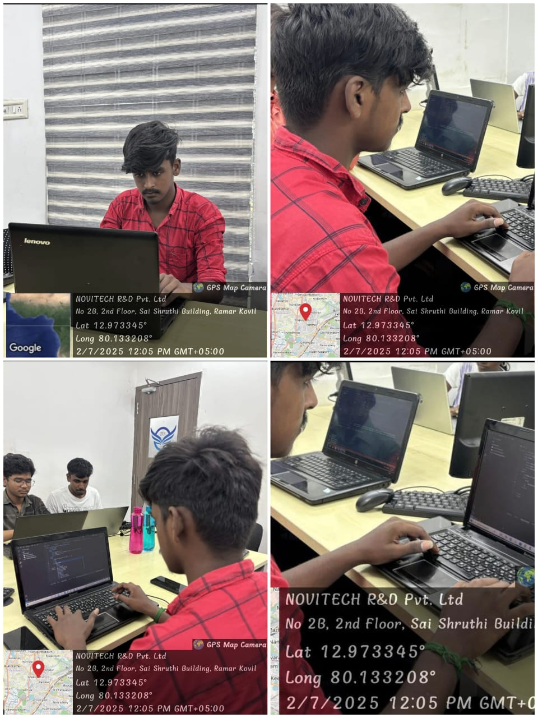
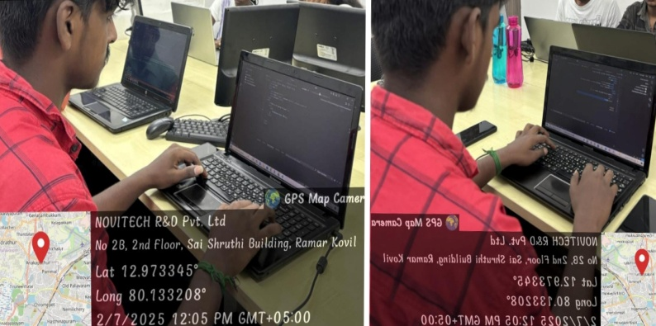

MENTOR HOD

INTERNSHIP CERTIFICATE
